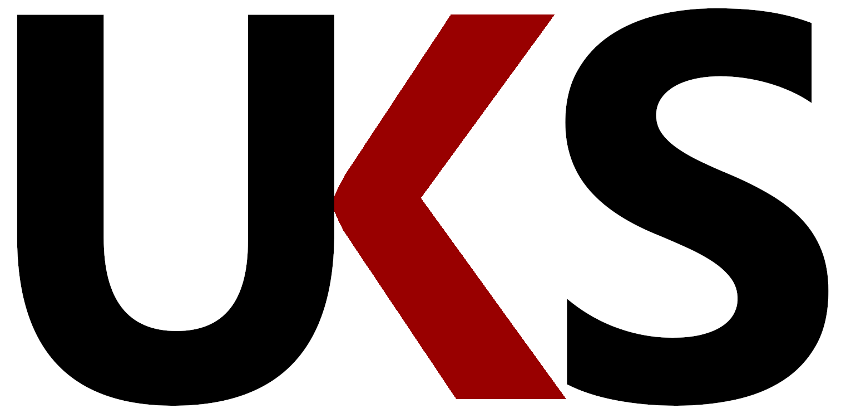

Press release - 07/02/2022

OPTIMAL UK announces company name change to UKS Distribution Limited
along with all new website

Automotive parts business OPTIMAL UK Distribution Ltd has announced changes in its company name and moving forward with immediate effect it shall be known as UKS Distribution Limited and use the new website: https://www.uksdistribution.com
Midlands-headquartered OPTIMAL UK was established in 2009 as a partnership between Geoff Jones and Germany-based OPTIMAL AG & Co. – which subsequently became part of LKQ Europe before Geoff purchased the UK operation outright in 2021.
Commenting on the name changes, Geoff Jones said: “We are proud of how we introduced and raised the awareness and product offering of the Optimal profile and products in the UK, to where it stands today, and there will be no major changes with our UK employees and customers. The OPTIMAL product range will still be available from us and promoted as the quality brand it is, but it will now be complemented by other equally-respected brands, all available in the UK and Ireland through the UKS distribution network and many more will join our ever-growing portfolio of brands.

Already in place at UKS are distribution agreements with, Optimal, Trico, Dolz, Arnott, Metzger, AL-KO and there are more to follow.
“We look forward to continuing to work with companies and brands that share our passion and strategy for the UK aftermarket. Motor Factors, whether independent or part of the many groups in the UK are very much our core market and we will continue to listen to them, work with them and create exciting opportunities together as part of this next chapter.”

Anthony Kitchen of EK Motor Factors added, “My company has been a distributor of quality parts to the workshop sector for over 50 years and working closely with Geoff and his family team has been a breath of fresh air. They know how to support us and what our requirements are and we will certainly be interested to see what other exciting brands they can offer us moving forward.”

Trico’s European Product Director Sam Robinson said, “working with UKS is exactly what we need for the UK aftermarket. They have an excellent relationship with their factor customers and our brand will only benefit from this new partnership.”

Picture caption 1: Geoff Jones, UKS Distribution Limited
Picture caption 2: UKS logo

For further information regarding this release about UKS Distribution

please contact Gary Barak at Chicane Mobile: 07973 159070
Off Tel: 01923 265894
email: gary@chicane.marketing
Web: www.chicane.marketing

Unit 1, Abbotts Business Park, Primrose Hill, Kings Langley, Hertfordshire. WD4 8FR

or
UKS Distribution Limited
Unit 12, Hereward Rise, Halesowen, West Midlands, B62 8AW
Tel.: 0121 550 2317 E-Mail: info@uksdistribution.com
Website: www.uksdistribution.com

